Article
Fine-Grained Assessment of COVID-19 Severity Based on Clinico-Radiological Data using Machine Learning
Haipeng Liu ¹, Jiangtao Wang ¹, Yayuan Geng ², Kunwei Li ³, Han Wu ⁴, Jian Chen ³, Xiangfei Chai ², Shaolin Li ^{3,5,}* and Dingchang Zheng ^{2,}*
Citation: Lastname, F.; Lastname, F.; Lastname, F. Title. Int. J. Environ. Res. Public Health 2022, 19, x. https://doi.org/10.3390/xxxxx
Academic Editor: Firstname Lastname
Received: date
Accepted: date
Published: date
Publisher’s Note: MDPI stays neutral with regard to jurisdictional claims in published maps and institutional affiliations.

Copyright: © 2022 by the authors. Submitted for possible open access publication under the terms and conditions of the Creative Commons Attribution (CC BY) license (https://creativecommons.org/licenses/by/4.0/).
¹ Research Centre for Intelligent Healthcare, Coventry University, Coventry CV1 5FB, UK; haipeng.liu@coventry.ac.uk (H.L.); jiangtao.wang@coventry.ac.uk (J.W.)
² Scientific Research Department, HY Medical Technology, B-2 Building, Dongsheng Science Park, Haidian District, Beijing, 100192, China; gengyayuan@126.com (Y.G.); chaixiangfei@huiyihuiying.com (X.C.)
³ Department of Radiology, The Fifth Affiliated Hospital, Sun Yat-sen University, Zhuhai, Guangdong Province, 519000, China; likunwei@mail.sysu.edu.cn (K.L.); drchenj@126.com (J.C)
⁴ College of Engineering, Mathematics and Physical Sciences, Streatham Campus, University of Exeter, North Park Road, Exeter, EX4 4QF, UK; hw630@exeter.ac.uk (H.W.);
⁵ Guangdong Provincial Key Laboratory of Biomedical Imaging, The Fifth Affiliated Hospital, Sun Yat-sen University, Zhuhai, Guangdong Province, 519000, China; gengyayuan@126.com (Y.G.);

* Correspondence: lishlin5@mail.sysu.edu.cn; dingchang.zheng@coventry.ac.uk
Abstract: Background: The severe and critical cases of COVID-19 had high mortality rate. Clinical features, laboratory data, and radiological features provided important reference for the assessment of COVID-19 severity. The machine learning analysis of clinico-radiological features, especially the quantitative computed tomography (CT) image analysis results, may achieve early, accurate, and fine-grained assessment of COVID-19 severity, which is an urgent clinical need. Objective: To evaluate if machine learning algorithms using CT-based clinico-radiological features could achieve accurate fine-grained assessment of COVID-19 severity. Methods: The clinico-radiological features were collected from 78 COVID-19 patients with different severities. A neural network was developed to automatically measure the lesion volume from CT images. The severity was clinically diagnosed using two-type (severe and non-severe) and fine-grained four-type (mild, regular, severe, critical) classifications respectively. To investigate the key features of COVID-19 severity, analysis of variance (ANOVA) was performed between patients’ clinico-radiological features and severity. Four machine learning algorithms (decision tree, random forest, SVM, and XGBoost) were trained and applied in the assessment of COVID-19 severity using clinico-radiological features. Results: The CT imaging features (CTscore and lesion volume) were significantly related with COVID-19 severity (p<0.05 in ANOVA for both in two-type and four-type classifications). The CT imaging features significantly improved the accuracy of machine learning algorithms in assessing COVID-19 severity in the fine-grained 4-type classification. Conclusion: CT-based clinico-radiological features can provide important reference for the accurate fine-grained assessment of illness severity using machine learning to achieve the early triage of COVID-19 patients.
Keywords: COVID-19; lesion volume measurement; clinico-radiological features; machine learning; fine-grained classification

1. Introduction
During the pandemic of COVID-19, it was observed that the mortality is significantly higher in severe and critical cases {Zhou, 2020 #1}[1]. After the occurrence of the symptoms of severe acute respiratory infection, some patients rapidly developed acute respiratory distress syndrome (ARDS) and other serious complications, which are followed by multiple organ failure [2]. Therefore, early diagnosis of severe and critical cases could optimize the distribution of medical resources, ensure early intervention for severe and critical patients, and finally reduce the mortality of COVID-19 [3].
Clinical features and laboratory data provided important reference for assessing the severity of COVID-19 [2,4]. Some physiological parameters such as respiratory rate (RR) and oxygen saturation (SpO2) have been suggested as the indicators of severe and critical cases in clinical guidelines [5]. Some metabolic disturbances and inflammatory dysfunctions [6] such as lymphopenia [7] and high level of lactate dehydrogenase [8] also have been proven as strong indicators of the severity of COVID-19. Additionally, some clinical comorbidities such as kidney diseases are related with the severity and mortality of COVID-19 [9,10].
Computed tomography (CT) imaging has been commonly applied in the diagnosis of COVID-19 [11]. With the deterioration of COVID-19 after the onset of symptoms, specific radiological characteristics such as consolidation, bilateral and peripheral disease, greater total lung involvement, linear opacities, “crazy-paving” pattern and the “reverse halo” sign, can be clearly observed on CT images [12]. Especially, the lesion volume automatically segmented from CT images showed a strong correlation to the prognostic severity of the COVID-19 illness [13]. It has been suggested that clinico-radiological features could indicate the severity of COVID-19 and be applied in the triage of patients [14,15].
Furthermore, based on the clinico-radiological features, various artificial intelligence (AI) methods, especially the machine learning algorithms, have been applied in the assessment of the severity of COVID-19 [16]. Shi et al. developed a least absolute shrinkage and selection operator (LASSO) logistic regression model to predict the prognostic severity of COVID-19 using clinico-radiological data. The authors found that the deep learning LASSO model was more efficient in predicting the severity of COVID-19 than the quantitative CT parameters and the pneumonia severity index (PSI) [17]. Zhang et al. developed a machine learning model using support vector machine (SVM) to predict the severity of COVID-19 based on 28 clinical features extracted from the results of blood and urine tests [18]. Tang et al. developed a random forest (RF) machine learning model to classify the severity (non-severe vs. severe) of COVID-19 infection based on the quantitative radiological features extracted from CT images, and concluded that the RF-based model can achieve automatic assessment of COVID-19 severity [19]. It was suggested that the lesion volume derived from the automatic quantitative analysis of CT images can be applied in the machine learning model to assess the severity of COVID-19 based on the clinico-radiological features [20].
However, the majority of existing studies are focused on the preliminary separation between severe and non-severe cases. The accurate detection and triage of severe and critical cases plays an important role in reducing the mortality of COVID-19 [3]. Therefore, more fine-grained classification of severity deserves further investigation. Additionally, in existing studies using machine learning algorithms, the clinico-radiological features related with the severity have not been comprehensively analyzed from a clinical and pathophysiological perspective. There is a high need to comprehensively evaluate the clinico-radiological features related to the severity of COVID-19, and develop the machine learning methods to achieve the early fine-grained assessment of COVID-19 severity.
In this study, based on the analysis of CT images using neural network, we aim to find the clinico-radiological features significantly related with the severity of COVID-19, and evaluate if machine learning algorithms could achieve accurate fine-grained assessment of COVID-19 severity using clinico-radiological features. This work will pave the way for the early triage of COVID-19 patients, which will optimize the distribution of medical resources during pandemic and effectively decrease the mortality of COVID-19 especially among the severe and critical cases.

2. Materials and Methods

2.1. Patient Recruitment
78 patients with confirmed SARS-CoV-2 laboratory test between Jan. 18 2020 and Mar. 5, 2020 in Zhuhai, China were recruited in a retrospective, single-center study. A patient was confirmed as positive by high-throughput sequencing or real-time reverse-transcriptase polymerase-chain-reaction (RT-PCR) assay of nasal and pharyngeal swab specimens. The RT-PCR test kits were manufactured by Shanghai Zhijiang Biotechnology Co. (Shanghai, China). This study was approved by the ethics committee of the Fifth Affiliated hospital of Sun Yat-Sen University and the requirement for informed consent was waived. The private information of patients was anonymized by the investigators after data collection. The inclusion criteria were: (a) patients with positive novel coronavirus nucleic acid antibody test and confirmed by the Centers for Disease Control (CDC); (b) age >=14. Patients with comorbidities of other respiratory diseases cardiovascular diseases, diabetes, and cancers were excluded.

2.2. Clinical Data Collection
Clinical data was collected by chart review. The patients were classified into four types according to patients’ most severe conditions, using the Diagnosis and Treatment Plan of COVID-19 issued by National Health Commission (7th ed.): (1) Mild type: minimal clinical symptoms without pneumonia in imaging; (2) Regular type: fever, respiratory and other symptoms with pneumonia in imaging; (3) Severe type: respiratory distress, respiratory rate ≥ 30 times/min; in resting state, oxygen saturation ≤ 93%; PaO2/FiO2 ≤ 300mmHg; (4) Critical type: respiratory failure requiring mechanical ventilation, shock and other organ failure requiring ICU monitoring and treatment [21].

2.3. CT Imaging Protocol
All scans were performed with patients in the supine position during end-inspiration without intravenous contrast on three CT scanners: uCT 760, uMI 780 scanners (United Imaging; Shanghai, China) and Precision 32 (CAMPO Imaging; Shenyang, China). Images were obtained from the apex to lung bases, using a standard dose protocol, reconstructed at 1.0 mm / 1.1 mm slice thickness, with 0.7 mm increment, 512 mm × 512 mm and a sharp reconstruction kernel. The lung window width and level settings were 1500 Hounsfield units (HU) and -600 HU.

2.4. CT Image Analysis

2.4.1. CTscore from Visual Quantitative Evaluation
The CTscore was obtained by visual quantitative evaluation of acute lung inflammatory lesion on CT images. In each lobe, the score was calculated from the percentage of total lesion areas as 0 (0%), 1 (1–25%), 2 (26–50%), 3 (51–75%), or 4 (76–100%). For each subject, by adding the scores of five lung lobes, the total severity score (CTscore) ranged from 0 to 20 [22].

2.4.2. MT-HRNet-3d Neural Network for Lesion Volume Measurement
The lesion volume was calculated based on an AI algorithm which was developed by HY Medical Technology Co.,Ltd (Beijing, China). The main neural network framework is detailed in Figure 1.
The original high-resolution network, named HRNetV1 [23], maintains high-resolution representations by exchanging information across multi-resolution subnetworks. HRNetV2 [24] explores the representations from all the high-to-low resolution parallel convolutions other than only the high-resolution representations in HRNetV1, which adds a small overhead and leads to stronger high-resolution representations. To achieve the three-dimensional (3d) medical image classification and segmentation, we modified the existing networks and built a 3d high-resolution network, named MT-HRNet-3d (3d Multi-Task High-Resolution Network).
As shown in Figure. 1, the MT-HRNet-3d network is composed of a simple stem, a main body, as well as the segmentation and classification subnets. The simple stem consists of one 2-strided convolutions decreasing the resolution, remaining the scale of the highest resolution at 2. The main body consists of four stages of parallel high-to-low resolution subnetworks, outputting the high-to-low resolution feature maps through repeatedly fusing the representations produced by the high-to-low subnetworks. With segmentation and classification subnets, the network is targeted for the 3d medical image classification and segmentation. In this study, we used the 3d lesion volume reconstructed from segmented masks of lesions (i.e., the output of segmentation subnet), as an input for the machine learning algorithm of severity classification. The segmentation subset had been trained and validated based on the consensus manual segmentation results of three radiological experts as the gold standard.
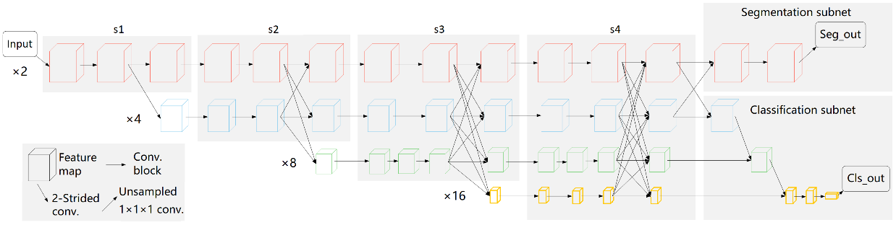
Figure 1. The network architecture of MT-HRNet-3d, composed of a simple stem, a main body, as well as the segmentation and classification subnets. The main body consists of four stages of parallel high-to-low resolution subnetworks with repeated information exchange across multi-resolution subnetworks (multi-scale fusion). ×n denotes the down-sampling ratio of the resolution representation to the input image, and the numbers of blocks of each stage module are [2, 2, 3, 3] in [×2, ×4, ×8, ×16] resolution levels, respectively. In the segmentation subnet, only the highest resolution representations are concatenated for the medical lesion segmentation, while in the classification subnet, all the high-to-low resolution representations are aggregated for multi-class classification. Seg_out and Cls_out are the outputs of two subnets. In this study, the lesion volume reconstructed from Seg_out result was used as an input of machine learning algorithm of severity classification.

2.4.3. Modification of Neural Network
Following [23], the widths (number of channels) of the convolutions of the four resolutions were C, 2C, 4C, and 8C, where C was set to 32. A simple modification in the main body was made by including each branch in the multi-resolution group convolution with different residual blocks to save the memory. Specifically, the four high-to-low resolution branches contain 2, 2, 3, and 3 blocks, respectively, where the 2nd, 3rd, and 4th stages contain 1, 2, and 2 multi-resolution modules.
Notably, we considered the HRNet as a naturally multi-task learning framework for the segmentation and classification, and believe that the good feature representations in different resolution can be learned by related multi-task learning. Therefore, the segmentation and classification subnets were added simultaneously. Instead of all the high-to-low resolution representations, only the highest resolution representations were concatenated for the medical lesion segmentation, resulting in fine segmentation contours. In the classification subnet, all the high-to-low resolution representations were aggregated for multi-class classification.

2.4.4. Multi-task Loss Function
A MT-HRNet-3d network has two sibling output subnets. The classification subnet outputs a discrete probability distribution (per Image), p = (p0, . . ., pK), over K + 1 categories. As usual, p is computed by a softmax over the K+1 outputs of a linear classifier. The segmentation subnet outputs a probability segmentation map with the same resolution as the input feature map of the main body, then the segmentation map is upsampled (2 times) to the input size by trilinear upsampling. To jointly train the model, the related multi-task loss is defined as,
L = L_{CE} + λ1_{mask}L_{Dice} (1)
in which L_{CE} is the cross-entropy loss for the image-level classification. The second task loss, L_{Dice}, is the dice loss, defined over the probability segmentation map and the pixel-level labeled mask. The indicator function 1_{mask} evaluates to 1 when the lesion mask is labeled and 0 otherwise. The hyper-parameter λ in Eq. 1 controls the balance between the two task losses, usually set to 1 based on our experience.

2.5. Data Cleansing
The full clinico-radiological features are listed in Table S1. Firstly, the columns unrelated with patients’ pathophysiological information ('MedNum', 'No') and columns that have no data ('LVEF', 'SO2', 'PO2', 'YHZS') were removed. Secondly, the columns with recordings from less than 10 cases ('Onset2Admi', 'Onset2CT1', 'Onset2CTPositive1', 'Onset2CTPeak') were removed. Finally, 59 clinico-radiological features were used for analysis.

2.6. Statistical Analysis
To evaluate if the clinico-radiological features, especially the CT imaging features (CTscore and VRmax), were significantly related with the prognostic severity of COVID-19, the analysis of variance (ANOVA) was performed between the clinico-radiological features and the severity in the two-type and four-type classifications respectively. Levene’s test was performed to assess the homogeneity of variance. For the parameters that unsatisfied the homogeneity of variance (p<0.05 in Levene’s test), the Welch’s ANOVA was performed as an alternative. The p-value less than 0.05 was considered as statistically significant.

2.7. Machine Learning Algorithms
The data were processed using four different classification algorithms: decision tree, random forest, SVM, and XGBoost. As aforementioned, 59 clinico-radiological features (bold in Table S1) were selected. After applying feature engineering, 37 features remained for algorithmic training. We found out that NtproBNP, LYM, LDH, and CRP were the four most indicative features.
The estimation of the patient’s severity was the output, based on the 2-type (non-severe and severe) and 4-type classifications (mild, regular, severe, critical) respectively. The dataset was split into the training set (80%) and testing set (20%) for the 5-fold cross validation. To investigate the significance of CT analysis results in assessing the severity, the assessment was performed with VRmax and CTscore included and excluded respectively. The precision, recall, and F1 values were used for the quantitative comparison of results.

3. Results

3.1. Statistical Analysis

3.1.1. Significant Clinico-Radiological Features in 2-type Classification
The homogeneity of variance was not satisfied in following clinico-radiological features: CK, NTproBNP, Cr, N2L1, WBC2, NEU2, N2L2, CRP2, VRmax, cTn1 (p<0.05 for all in Levene’s test). In the ANOVA and Welch’s ANOVA, the clinico-radiological features that are significantly different in severe and non-severe cases are shown in Table 1.
Table 1. Statistically significant clinico-radiological features of severity in 2-type classification
Clinico-radiological features | p-value in ANOVA or Welch’s ANOVA
Age | 0.005
LDH | <0.001
HBDH | <0.001
LYM1 | 0.01
CRP1 | 0.002
CRP2 | <0.001
N2L1 | 0.02
N2L2 | 0.006
ALB1 | 0.003
ALB2 | <0.001
NTproBNP | 0.001
CTscore | <0.001
VRmax | <0.001

3.1.2. Significant Clinico-Radiological Features in 4-type Classification
The homogeneity of variance was not satisfied in following clinico-radiological features: Height, CK, NTproBNP, Cr, N2L1, CRP1, NEU2, N2L2, CRP2, VRmax, cTn1 (p<0.05 in Levene’s test). In the ANOVA and Welch’s ANOVA, the clinico-radiological features that are significantly different among the patients with different severities are shown in Table 2. In both the 2-type and 4-type classifications, the CT imaging features were significantly related with the severity of COVID-19.
Table 2. Statistically significant clinico-radiological features of severity in 4-type classification
Clinico-radiological features | p-value in ANOVA or Welch’s ANOVA
Age | 0.002
LDH | <0.001
HBDH | <0.001
LYM1 | 0.001
CRP2 | 0.002
N2L2 | 0.028
ALB1 | 0.003
ALB2 | <0.001
NTproBNP | 0.006
CTscore | <0.001
VRmax | 0.011

3.2. Machine Learning

3.2.1. Role of CT Images Analysis in 2-type Classification
As shown in Table 3, overall, the addition of AI-assisted CT image analysis results (radiological features) did not improve the accuracy of the algorithms in 2-type classification. Only the F1 value of Decision algorithms showed mild improvement.
Table 3. Estimation results of machine learning algorithms in 2-type classification*
 | Classifier | Without CT Image Analysis |  |  |  | With CT Image Analysis
 |  | Cross Validation | Test Set |  |  | Cross Validation | Test Set
 |  | F1 | Precision | Recall | F1 | F1 | Precision | Recall | F1
2-type classification | Decision Tree | 0.57 | 0.89 | 0.75 | 0.86 | 0.61 | 0.67 | 0.50 | 0.57
2-type classification | Random Forest | 0.67 | 0.67 | 0.25 | 0.40 | 0.64 | 0.67 | 0.25 | 0.40
2-type classification | SVM | 0.67 | 0.67 | 0.25 | 0.40 | 0.67 | 0.67 | 0.25 | 0.40
2-type classification | XGBoost | 0.71 | 0.78 | 1.00 | 0.80 | 0.68 | 0.78 | 1.00 | 0.80
4-type (fine-grained) classification | Decision Tree | 0.53 | 0.13 | 0.25 | 0.17 | 0.77 | 0.56 | 0.50 | 0.52
4-type (fine-grained) classification | Random Forest | 0.55 | 0.50 | 0.42 | 0.36 | 0.78 | 0.76 | 0.75 | 0.75
4-type (fine-grained) classification | SVM | 0.52 | 0.50 | 0.42 | 0.36 | 0.52 | 0.50 | 0.42 | 0.36
4-type (fine-grained) classification | XGBoost | 0.49 | 0.50 | 0.42 | 0.36 | 0.80 | 0.86 | 0.75 | 0.71
*The bold font shows the improvements in performance due to CT image analysis

3.2.2. Role of CT Images Analysis in 4-type Classification
In Table 3, it can be observed that with the addition of AI-assisted CT images analysis, the accuracy of the estimation has been improved in Decision Tree, Random Forest, and XGBoost but not in SVM.

3.2.3. Patient-Specific Analysis of Significant Clinico-Radiological Features in Machine Learning
Figure 2a shows a severe case in 2-type classification. The existence of arrhythmia and fatigue, which may be related with cardiac diseases and the development of COVID-19, indicate higher severity. The phlegm showed the opposite relationship with severity. A possible explanation is that, the lack of phlegm will make it difficult for the patient to expel the sputum from the lung, which will deteriorate the affection in the lung and lead to higher severity. Figure 2b shows a severe and a regular cases in four-type classification. It can be seen that the key clinico-radiological features are different from the two-type classification in Figure 2a, where the CTscore becomes a key factor.
Figure 3 shows two cases with similarity in many clinical features. With the machine learning method, they have been accurately classified as non-severe and severe, and regular and severe, in the two-type and four-type classifications respectively. It can be observed that the CTscore showed significant difference between the two cases, which improved the accuracy of classification.
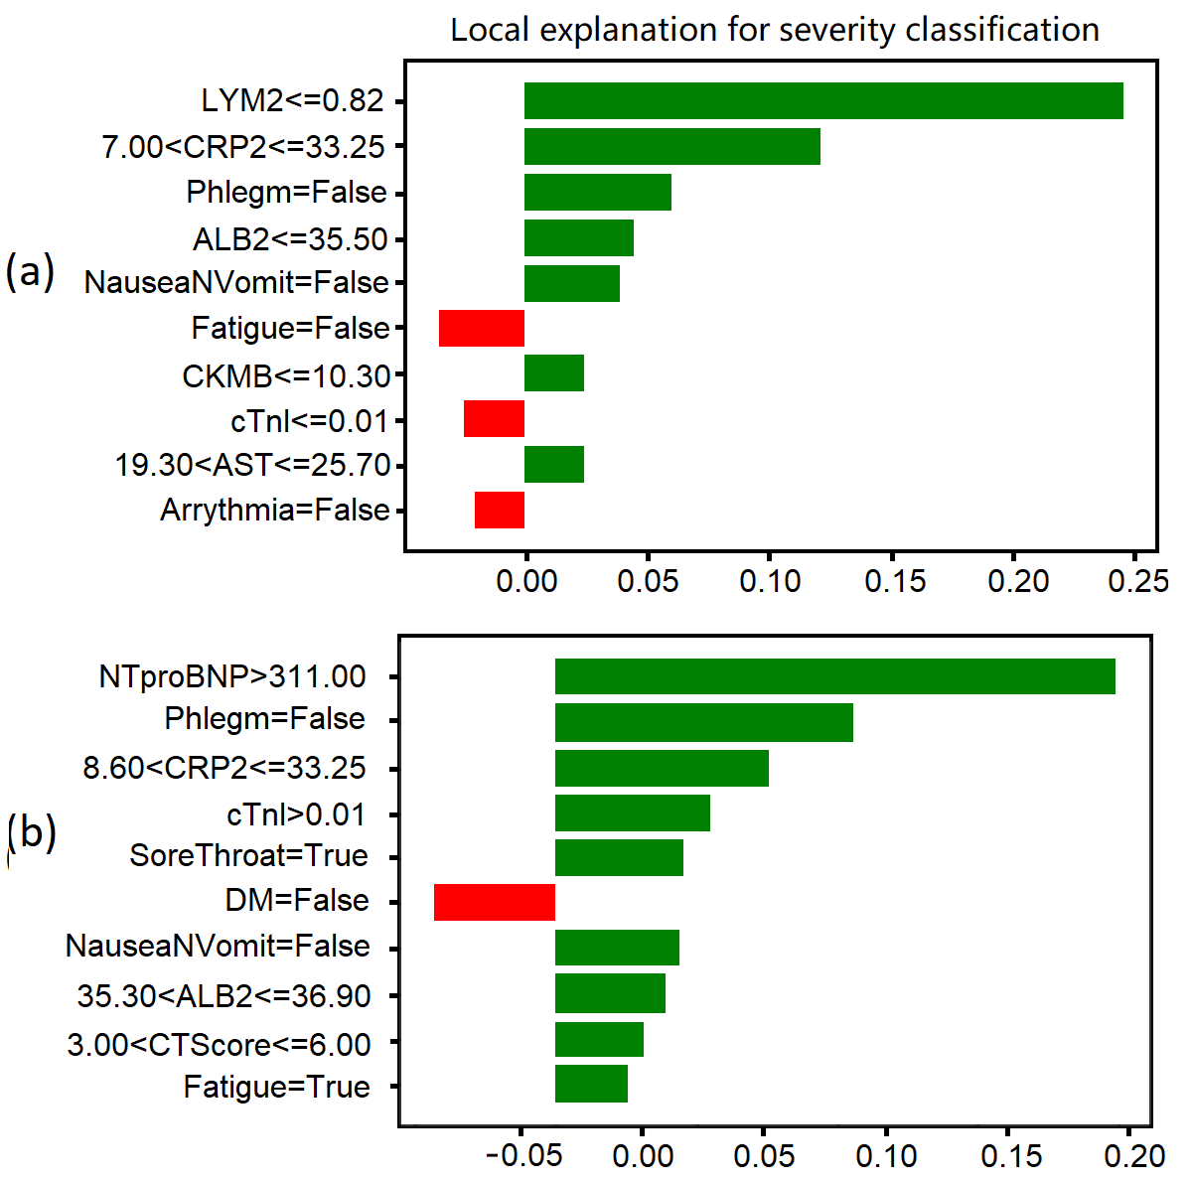
Figure 2. Comparison of clinico-radiological features in different cases. (a) A severe and a non-severe cases in two-type classification. (b) A severe and a regular cases in four-type classification. Features in green and red have a positive and negative effect on the classification, respectively.

4. Discussion

4.1. Comparison between Statistical Analysis and Machine Learning Results
In statistical analysis, the CT image analysis results (CTscore and VRmax) were significant features of the severity in both 2-type (p<0.001 for both) and 4-type (p<0.001 and p=0.011) classifications. The inclusion of CT image analysis results significantly improved the accuracy of machine learning algorithms in evaluating the severity of COVID-19 using 4-type classification. These results commonly suggest that CT image analysis could provide important reference for the fine-grained assessment of illness severity to achieve the early triage of COVID-19 patients. Compared with the statistical analysis, the machine learning algorithms provided the patient-specific quantitative evaluation of different clinico-radiological features regarding the illness severity, providing a more detailed reference for the accurate diagnosis and treatment of COVID-19.

4.2. Quantitative CT Image Analysis: a Key to COVID-19 Severity Assessment
It has been suggested that CT image analysis could improve the machine learning algorithm to achieve a higher accuracy in diagnosing COVID-19 than the clinical COVID-19 reporting and data system [25]. Especially, the lesion volume segmented and quantified using deep learning showed a strong potential in the prediction of COVID-19 severity [26]. Furthermore, the ratio of compromised lung volume (sum of poorly and non-aerated volumes) has been observed to be an accurate outcome predictor of the risk of oxygenation support and intubation, and in-hospital mortality (p < 0.001 for all in logistic regression) [27]. Therefore, the quantitative CT image analysis (especially the lesion volume) plays a key role in the assessment of the severity of COVID-19, and provides important reference to guide the clinical triage and intervention.
According to the model interpretation (2-type XGBoost classification), the model unveils several important clinic-radiological features such as NTproBNP. As a result, among all those important features, the CTscore improves the performance only moderately. For the 4-type classification, the CTscore improves in all classification algorithms but not in SVM due to its structure. The SVM model decides its hyperplane based on all the features. The CTscore does have influence on the decision of the hyperplane, but its influence is not strong enough to demonstrate its efficacy on the final decision.

4.3. Fine-Grained Severity Assessment of COVID-19 Using Machine Learning: Clinical Significance
Considering the current epidemic of COVID-19 and the high risk of recurrence, the early detection of severe COVID-19 illness is an urgent clinical need. Currently, both the two-type [28] and four-type [29] classification standards are widely used in the triage of COVID-19 patients. In the latest guidelines of Chinese Medical Association, the severe and critical cases of COVID-19 were unified as “severe” due to the rapid exacerbation of severe cases, the highly diverse “time window”, and the difficulty in detecting critical cases which may lead to the delayed treatment [30]. The time lengths from illness onset to severe symptoms such as dyspnoea (95% confidence interval (CI): 4.0-9.0 days) or critical symptoms such as sepsis (95% CI: 7.0-13.0 days) are patient-specific and covers a wide range [1]. Additionally, the RT-PCT test has low sensitivity in the first 3-5 days of affection [31]. Therefore, the early and accurate detection of clinical risks based on the four-type classification could play an important role in guiding the clinical intervention for the severe and critical cases. Additionally, due to the rapidly growing imbalance between supply and demand for medical resources, the fair allocation of medical resources has become an urgent clinical need in many countries [32]. With accurate estimation of severity, this machine learning method could be used to guide the allocation of limited medical resources.
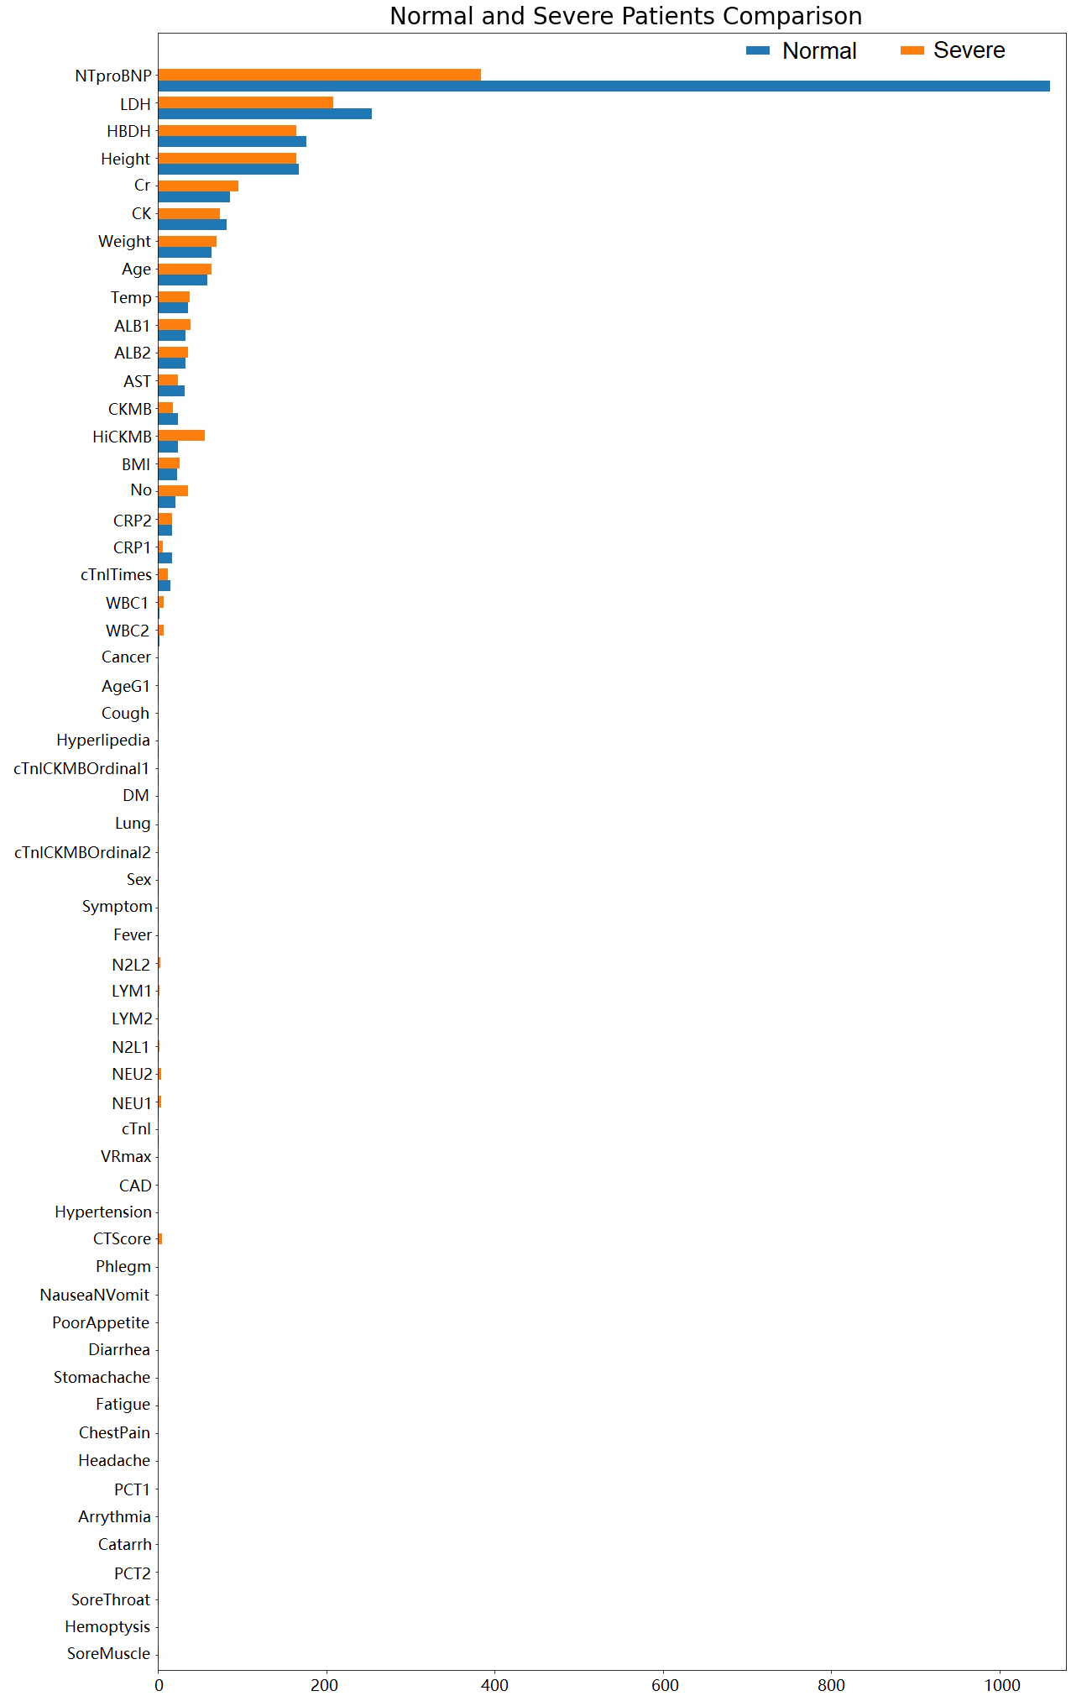
Figure 3. Comparison of clinico-radiological features between a non-severe case and a severe case.

4.4. Limitations and Future Directions
Firstly, only 78 patients were included in this single-center, retrospective pilot study. Secondly, the distributions of age and severity were imbalanced in these cases. There were only 5 cases aged 19-30 years and only one case aged less than 18 years. The majority (57.5%) of the included cases were moderate. Only five critical cases were included. Additionally, it has been found the severity of COVID-19 was related with other physiological factors including pregnancy [14], and the comorbidity of chronical respiratory diseases, cardiovascular diseases [10], diabetes [33], and cancer [34]. Therefore, the results derived by the machine learning models need to be validated in large-scale datasets to consider more pathological factors. In future studies, more clinical datasets could be included to cover a wider range of age and severity, as well as those in different physiological and pathological conditions.

5. Conclusions
The results of quantitative CT image analysis were significantly related to the severity of COVID-19. The clinico-radiological features including the CT image analysis results can provide important reference for the fine-grained assessment of illness severity using machine learning to achieve the early triage of COVID-19 patients.

Author Contributions: Conceptualization, X.C., S.L. and D.Z.; methodology, H.L., J.W., Y.G., and H.W.; software, Y.G., X.C.; validation, Y.G., K.L., H.W. and J.C.; formal analysis, H.L. and H.W.; investigation, H.L. Y.G. and H.W.; resources, X.C., S.L. and D.Z.; data curation, K.L., J.C and S.L.; writing—original draft preparation, H.L. and H.W.; writing—review and editing, H.L, J.W., Y.G. and H.W.; visualization, Y.G. and H.W.; supervision, X.C, S.L. and D.Z.; project administration, X.C. and S.L..; funding acquisition, X.C. and D.Z. All authors have read and agreed to the published version of the manuscript.
Funding: This research received no external funding.
Institutional Review Board Statement: This study was approved by the ethics committee of the Fifth Affiliated hospital of Sun Yat-Sen University and the requirement for informed consent was waived due to the retrospective nature of the study and the analysis used anonymous clinical data.
Informed Consent Statement: Patient consent was waived due to the retrospective nature of the study and the analysis used anonymous clinical data..
Data Availability Statement: Not applicable.
Acknowledgments: We acknowledge the Fifth Affiliated hospital of Sun Yat-Sen University for sharing the data for analysis.
Conflicts of Interest: The authors declare no conflict of interest.
Appendix A
TABLE S1
Clinico-radiological features
Feature | Note | Category
MedNum | Number of Medical Insurance | x
No | Number | x
Sex | Sex | Basic imformation
Age | Age | Basic imformation
AgeG1 | Age>50 | Basic imformation
Height | Height | Basic imformation
Weight | Weight | Basic imformation
BMI | Body Mass Index | Basic imformation
Temp | Body temperature
Severity03 | Severity 0-3: mild, regular, severe, critical | Categories of severity
Severity01 | Severity 0-1: non-severe, severe | Categories of severity
CTscore | Peak CT scores | Visual quantification on CT images
VRmax | The highest value of the affected Volume Ratio among all CT scans for the particular patient. | Detection results derived by algorithm
cTnITimes | Time of cTnI measurement | Reagent Test
cTnI | Maximal Cardiac troponin | Reagent Test
cTnlCKMBOrdinal1 | Whether troponin is elevated during the disease | Reagent Test
cTnlCKMBOrdinal2 | Whether CKMB is elevated during the disease | Reagent Test
AST | Maximal aminotransferase. AST level in serum is a clinical indicator of myocardial infarction and myocarditis, which is low in normal cases. | Biochemical marker
LDH | Lactate dehydrogenase. Increased activity of LDH activity is mainly found in myocardial infarction, acute or chronic hepatitis, and liver cancer. | Biochemical marker
CK | Creatine kinase,an indicator of myocardial diseases | Biochemical marker
CKMB | Creatine kinase myocardial band, a specific serum marker of cardiomyocyte damage | Biochemical marker
HBDH | α-hydroxybutyrate dehydrogenase, which actually reflect the activity of LDH1 and LDH2, which is has diagnostic significance of myocardial and liver diseases | Biochemical marker
HiCKMB | Highest level of CKMB | Biochemical marker
NTproBNP | N-terminal pro b-type natriuretic peptide,for clinical diagnosis of heart failure | Biochemical marker
Cr | Serum creatinine | Biochemical marker
LVEF | left ventricular ejection fraction (maximum) not included in the majority | Color doppler ultrasonic
PCT1 | procalcitonin,which increases during bacterial, fungal, and parasitic infections as well as sepsis and multiple organ failure, maximal value on admission | Inflammation marker
WBC1 | white blood cells on admission | Blood routine examination
NEU1 | Neutrophils on admission | Blood routine examination
LYM1 | Lymphocytes on admission | Blood routine examination
N2L1 | Ratio of granulocytes to lymphocytes on admission | Blood routine examination
CRP1 | C-reactive protein (CRP) on admission, which rises sharply in plasma due to infection or tissue damage | Inflammation marker
ALB1 | Albumin (on admission) | Biochemical marker
PCT2 | Procalcitonin (maximum values for non-severe patients or pre-severe phase of severe patients) | Inflammation marker
WBC2 | white blood cells (maximum values for non-severe patients or pre-severe phase of severe patients) | Blood routine examination
NEU2 | Neutrophils(maximum values for non-severe patients or pre-severe phase of severe patients) | Blood routine examination
LYM2 | Lymphocytes (maximum values for non-severe patients or pre-severe phase of severe patients) | Blood routine examination
N2L2 | Ratio of granulocytes to lymphocytes (maximum values for non-severe patients or pre-severe phase of severe patients) | Blood routine examination
CRP2 | C-reactive protein (maximum values for non-severe patients or pre-severe phase of severe patients) | Inflammation marker
ALB2 | Albumin (maximum values for non-severe patients or pre-severe phase of severe patients) | Biochemical marker
SO2 | x | x
PO2 | x | x
YHZS | x | x
Symptom | Symptoms on admission | Basic symptom
Fever |  | Basic symptom
Cough |  | Basic symptom
Phlegm |  | Basic symptom
Hemoptysis |  | Basic symptom
SoreThroat | Sore throat | Basic symptom
Catarrh |  | Basic symptom
Headache |  | Basic symptom
ChestPain | Chest pain | Basic symptom
Fatigue |  | Basic symptom
SoreMuscle | Sore muscle | Basic symptom
Stomachache |  | Basic symptom
Diarrhea |  | Basic symptom
PoorAppetie | Poor appetite | Basic symptom
NauseaNVomit | Nausea and Vomit | Basic symptom
Hypertention |  | Medical history
Hyperlipedia |  | Medical history
DM | Diabetes mellitus | Medical history
Lung | Lung diseases | Medical history
CAD | Coronary artery disease | Medical history
Arrythmia | Arrythmia | Medical history
Cancer | Cancer | Medical history
Onset2Admi | The time period from onset of symptoms to admission | Time
Onset2CT1 | The time period from onset of symptoms to the first CT imaging | Time
Onset2CTPositive1 | The time period from onset of symptoms to the first CT Positive results | Time
Onset2CTPeak | The time period from onset of symptoms to CT Peak results | Time
Selected clinic-radiological features are in bold

References
1. Zhou, F.; Yu, T.; Du, R.; Fan, G.; Liu, Y.; Liu, Z.; Xiang, J.; Wang, Y.; Song, B.; Gu, X.; et al. Clinical course and risk factors for mortality of adult inpatients with COVID-19 in Wuhan, China: a retrospective cohort study. The Lancet 2020, 395, 1054-1062, doi:https://doi.org/10.1016/S0140-6736(20)30566-3.
2. Gao, Y.; Li, T.; Han, M.; Li, X.; Wu, D.; Xu, Y.; Zhu, Y.; Liu, Y.; Wang, X.; Wang, L. Diagnostic utility of clinical laboratory data determinations for patients with the severe COVID-19. Journal of Medical Virology 2020, 92, 791-796, doi:https://doi.org/10.1002/jmv.25770.
3. Sun, Q.; Qiu, H.; Huang, M.; Yang, Y. Lower mortality of COVID-19 by early recognition and intervention: experience from Jiangsu Province. Annals of Intensive Care 2020, 10, 33, doi:10.1186/s13613-020-00650-2.
4. Wang, Y.; Wang, Y.; Chen, Y.; Qin, Q. Unique epidemiological and clinical features of the emerging 2019 novel coronavirus pneumonia (COVID-19) implicate special control measures. Journal of Medical Virology 2020, 92, 568-576, doi:10.1002/jmv.25748.
5. Organization, W.H. Clinical management of severe acute respiratory infection (SARI) when COVID-19 disease is suspected: interim guidance, 13 March 2020; World Health Organization: 2020.
6. Nie, S.; Zhao, X.; Zhao, K.; Zhang, Z.; Zhang, Z.; Zhang, Z. Metabolic disturbances and inflammatory dysfunction predict severity of coronavirus disease 2019 (COVID-19): a retrospective study. medRxiv 2020, 2020.2003.2024.20042283, doi:10.1101/2020.03.24.20042283.
7. Tan, L.; Wang, Q.; Zhang, D.; Ding, J.; Huang, Q.; Tang, Y.-Q.; Wang, Q.; Miao, H. Lymphopenia predicts disease severity of COVID-19: a descriptive and predictive study. Signal Transduction and Targeted Therapy 2020, 5, 33, doi:10.1038/s41392-020-0148-4.
8. Han, Y.; Zhang, H.; Mu, S.; Wei, W.; Jin, C.; Tong, C.; Song, Z.; Zha, Y.; Xue, Y.; Gu, G. Lactate dehydrogenase, an independent risk factor of severe COVID-19 patients: a retrospective and observational study. Aging 2020, 12, 11245-11258, doi:10.18632/aging.103372.
9. Cheng, Y.; Luo, R.; Wang, K.; Zhang, M.; Wang, Z.; Dong, L.; Li, J.; Yao, Y.; Ge, S.; Xu, G. Kidney disease is associated with in-hospital death of patients with COVID-19. Kidney International 2020, 97, 829-838, doi:https://doi.org/10.1016/j.kint.2020.03.005.
10. Wang, X.; Fang, X.; Cai, Z.; Wu, X.; Gao, X.; Min, J.; Wang, F. Comorbid Chronic Diseases and Acute Organ Injuries Are Strongly Correlated with Disease Severity and Mortality among COVID-19 Patients: A Systemic Review and Meta-Analysis. Research 2020, 2020, 17, doi:10.34133/2020/2402961.
11. Li, Y.; Xia, L. Coronavirus Disease 2019 (COVID-19): Role of Chest CT in Diagnosis and Management. American Journal of Roentgenology 2020, 1-7, doi:10.2214/AJR.20.22954.
12. Bernheim, A.; Mei, X.; Huang, M.; Yang, Y.; Fayad, Z.A.; Zhang, N.; Diao, K.; Lin, B.; Zhu, X.; Li, K.; et al. Chest CT Findings in Coronavirus Disease-19 (COVID-19): Relationship to Duration of Infection. Radiology 2020, 200463, doi:10.1148/radiol.2020200463.
13. Liu, F.; Zhang, Q.; Huang, C.; Shi, C.; Wang, L.; Shi, N.; Fang, C.; Shan, F.; Mei, X.; Shi, J.; et al. CT quantification of pneumonia lesions in early days predicts progression to severe illness in a cohort of COVID-19 patients. Theranostics 2020, 10, 5613-5622, doi:10.7150/thno.45985.
14. Liu, F.; Liu, H.; Hou, L.; Li, J.; Zheng, H.; Chi, R.; Lan, W.; Wang, D. Clinico-Radiological Features and Outcomes in Pregnant Women with COVID-19 Pneumonia Compared with Age-Matched Non-Pregnant Women. Infect Drug Resist 2020, 13, 2845-2854, doi:10.2147/IDR.S264541.
15. Shi, W.; Peng, X.; Liu, T.; Cheng, Z.; Lu, H.; Yang, S.; Zhang, J.; Wang, M.; Gao, Y.; Shi, Y.; et al. A deep learning-based quantitative computed tomography model for predicting the severity of COVID-19: a retrospective study of 196 patients. 2021 2021, 9, 216, doi:10.21037/atm-20-2464.
16. Shi, F.; Wang, J.; Shi, J.; Wu, Z.; Wang, Q.; Tang, Z.; He, K.; Shi, Y.; Shen, D. Review of Artificial Intelligence Techniques in Imaging Data Acquisition, Segmentation and Diagnosis for COVID-19. IEEE Reviews in Biomedical Engineering 2020, 1-1, doi:10.1109/RBME.2020.2987975.
17. Shi, W.; Peng, X.; Liu, T.; Cheng, Z.; Lu, H.; Yang, S.; Zhang, J.; Li, F.; Wang, M.; Zhang, X. Deep Learning-Based Quantitative Computed Tomography Model in Predicting the Severity of COVID-19: A Retrospective Study in 196 Patients. 2020.
18. Zhang, N.; Zhang, R.; Yao, H.; Xu, H.; Duan, M.; Xie, T.; Pan, J.; Huang, J.; Zhang, Y.; Xu, X. Severity Detection For the Coronavirus Disease 2019 (COVID-19) Patients Using a Machine Learning Model Based on the Blood and Urine Tests. 2020.
19. Tang, Z.; Zhao, W.; Xie, X.; Zhong, Z.; Shi, F.; Liu, J.; Shen, D. Severity assessment of coronavirus disease 2019 (COVID-19) using quantitative features from chest CT images. arXiv preprint arXiv:2003.11988 2020.
20. Cai, W.; Liu, T.; Xue, X.; Luo, G.; Wang, X.; Shen, Y.; Fang, Q.; Sheng, J.; Chen, F.; Liang, T. CT Quantification and Machine-learning Models for Assessment of Disease Severity and Prognosis of COVID-19 Patients. Academic Radiology 2020, 27, 1665-1678, doi:https://doi.org/10.1016/j.acra.2020.09.004.
21. National Health Commission, N.A.o.T.C.M. Translation: Diagnosis and Treatment Protocol for Novel Coronavirus Pneumonia (Trial Version 7). Infectious Microbes & Diseases 2020, 2, 6, doi:10.1097/IM9.0000000000000022.
22. Li, K.; Fang, Y.; Li, W.; Pan, C.; Qin, P.; Zhong, Y.; Liu, X.; Huang, M.; Liao, Y.; Li, S. CT image visual quantitative evaluation and clinical classification of coronavirus disease (COVID-19). European Radiology 2020, 30, 4407-4416, doi:10.1007/s00330-020-06817-6.
23. Sun, K.; Xiao, B.; Liu, D.; Wang, J. Deep High-Resolution Representation Learning for Human Pose Estimation. In Proceedings of the 2019 IEEE/CVF Conference on Computer Vision and Pattern Recognition (CVPR), 15-20 June 2019, 2019; pp. 5686-5696.
24. Sun, K.; Zhao, Y.; Jiang, B.; Cheng, T.; Xiao, B.; Liu, D.; Mu, Y.; Wang, X.; Liu, W.; Wang, J.J.a.p.a. High-resolution representations for labeling pixels and regions. 2019.
25. Liu, H.; Ren, H.; Wu, Z.; Xu, H.; Zhang, S.; Li, J.; Hou, L.; Chi, R.; Zheng, H.; Chen, Y.; et al. CT radiomics facilitates more accurate diagnosis of COVID-19 pneumonia: compared with CO-RADS. Journal of Translational Medicine 2021, 19, 29, doi:10.1186/s12967-020-02692-3.
26. Shan, F.; Gao, Y.; Wang, J.; Shi, W.; Shi, N.; Han, M.; Xue, Z.; Shen, D.; Shi, Y. Abnormal Lung Quantification in Chest CT Images of COVID-19 Patients with Deep Learning and its Application to Severity Prediction. Medical Physics 2020, n/a, doi:https://doi.org/10.1002/mp.14609.
27. Lanza, E.; Muglia, R.; Bolengo, I.; Santonocito, O.G.; Lisi, C.; Angelotti, G.; Morandini, P.; Savevski, V.; Politi, L.S.; Balzarini, L. Quantitative chest CT analysis in COVID-19 to predict the need for oxygenation support and intubation. European Radiology 2020, 30, 6770-6778, doi:10.1007/s00330-020-07013-2.
28. Ye, Z.; Rochwerg, B.; Wang, Y.; Adhikari, N.K.; Murthy, S.; Lamontagne, F.; Fowler, R.A.; Qiu, H.; Wei, L.; Sang, L. Treatment of patients with nonsevere and severe coronavirus disease 2019: an evidence-based guideline. CMAJ 2020.
29. Organization, W.H. Operational considerations for case management of COVID-19 in health facility and community: interim guidance, 19 March 2020; World Health Organization: 2020.
30. 中华医学会重症医学分会; 中国医师协会重症医学医师分会; 中国病理生理学会危重病医学专业委员会. 重症新型冠状病毒肺炎管理专家推荐意见. 中华重症医学电子杂志 2020, E026-E026.
31. Zu, Z.Y.; Jiang, M.D.; Xu, P.P.; Chen, W.; Ni, Q.Q.; Lu, G.M.; Zhang, L.J. Coronavirus Disease 2019 (COVID-19): A Perspective from China. Radiology 2020, 296, E15-E25, doi:10.1148/radiol.2020200490.
32. Emanuel, E.J.; Persad, G.; Upshur, R.; Thome, B.; Parker, M.; Glickman, A.; Zhang, C.; Boyle, C.; Smith, M.; Phillips, J.P. Fair Allocation of Scarce Medical Resources in the Time of Covid-19. New England Journal of Medicine 2020, 382, 2049-2055, doi:10.1056/NEJMsb2005114.
33. Mithal, A.; Jevalikar, G.; Sharma, R.; Singh, A.; Farooqui, K.J.; Mahendru, S.; Krishnamurthy, A.; Dewan, A.; Budhiraja, S. High prevalence of diabetes and other comorbidities in hospitalized patients with COVID-19 in Delhi, India, and their association with outcomes. Diabetes & Metabolic Syndrome: Clinical Research & Reviews 2021, 15, 169-175, doi:https://doi.org/10.1016/j.dsx.2020.12.029.
34. Pathania, A.S.; Prathipati, P.; Abdul, B.A.; Chava, S.; Katta, S.S.; Gupta, S.C.; Gangula, P.R.; Pandey, M.K.; Durden, D.L.; Byrareddy, S.N.; et al. COVID-19 and Cancer Comorbidity: Therapeutic Opportunities and Challenges. Theranostics 2021, 11, 731-753, doi:10.7150/thno.51471.

